Database First approach in EF Core

Create new web api Project

Install the packages

Microsoft.EntityFrameworkCore.SqlServer

Microsoft.EntityFrameworkCore.Tools

Microsoft.EntityFrameworkCore.Design

Open Nuget Package Manager Console

Scaffold-DbContext "Server=LAPTOP-0TBPBTEL\SQLEXPRESS;Database=BikeStores;Integrated Security=True;TrustServerCertificate=True;" Microsoft.EntityFrameworkCore.SqlServer -OutputDir Models

After execution of above command in Package Manager Console -> It create a newfolder with the name of Models within the model it will create classes for tables. With Context class as our database is Bikestores our context class name is BikeStoresContext

Program.cs

builder.Services.AddDbContext<BikeStoresContext>(options =>

options.UseSqlServer(builder.Configuration.GetConnectionString("BikeStoresDatabase")));

Right Click on Controllers folder 🡺 Add New Controller

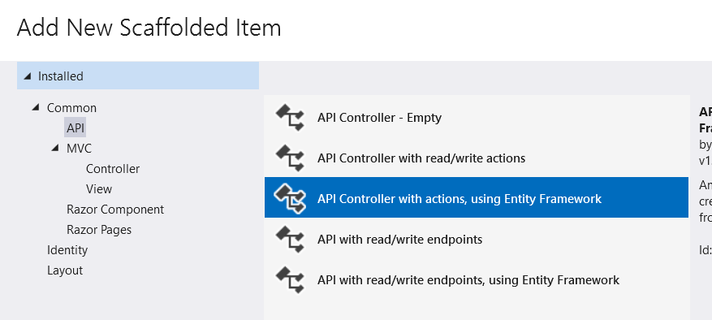

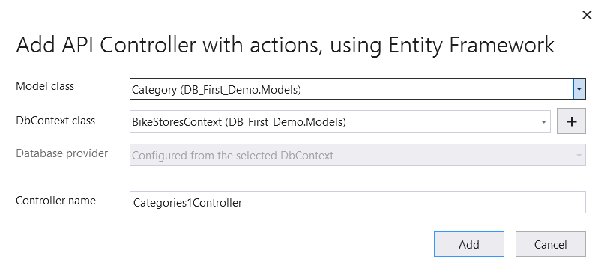

Then it will create a controller with Model class we choose and add all Endpoints like below

Execute and check the endpoints.